Smart Classroom Quick Guide
Quick Guide

Start Up
Make sure that the main power switch is turned on. This switch is located in the upper right hand corner inside the cabinet containing the DVD and VCR players. Once activated it should glow orange. If you are going to use a laptop you must first connect to the port on the sympodium. The plug is located near the lamps; plug the switch into the back of the laptop where one would usually plug in the projector adapter. If you don’t see the laptop’s desktop appear on the big screen press Fn F8.

Step 1: Turn on Projector; hold down the Display Power button located on the top
left corner of the control panel till the green light turns on.
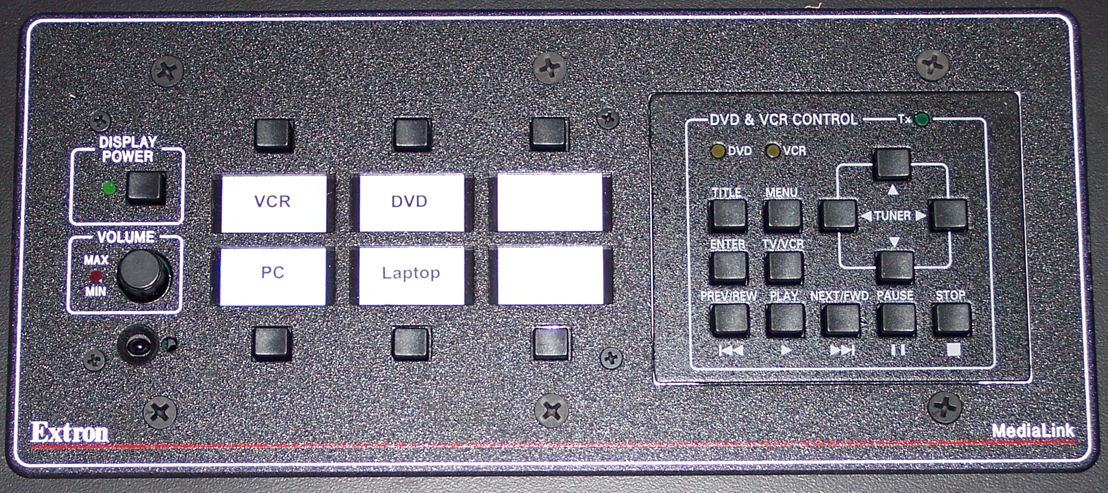
Input switch: Allows one to switch between input devices
Display Power
Step 2: Select Device; the buttons to select input devices are located in the center
of the control panel.

Step 3: Activate Smart Board Tool; double click on Smart Board Tool located on the desktop.

Step 4: Locate The Smart Board Tool bar. 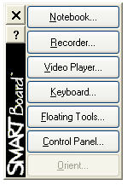

Step 5: From the Smart Board Tool, choose the floating tool; now that you have the
floating tools you can now begin to use them with any of your applications. 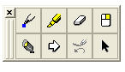
Step 5: Opening files. Open your file as you would normally. You may either use
the stylus or the mouse. Hint: It might be easier to use the mouse except
when writing.

Step 6: Using Floating tool. Once the file you wanted is open, use the stylus and
choose the appropriate tool you wish to use from the floating toolbar. If
you choose the pen or highlighter tool you can change the ink color by
selecting from the three different options available at the top of the
Sympodium. Just click on the different color ink pens to
automatically change colors. You may also select the eraser or mouse
cursor at the top of the Sympodium.

Shutdown
It is recommended that you do not turn off the main power switch. However you do need to shutdown the PC and turn off the Sympodium. Also turn off the projector by holding down the Power Display button till the green light blinks. The projector will not power down immediately due to cooling system.

